Fisher Family Trust – Success for All Phonics
Reading Fluency

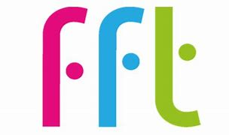

As families are aware, we follow Fisher Family Trust’s Success for all Phonics Scheme from Nursery to Year 2. In Reception, Year 1 and Year 2, pupils apply their phonic knowledge so they can decode (segment and blend) words for reading. Each day, children are taught specific skills linked to letters (graphemes) and their sounds (phonemes). They learn to recognise individual letters and their names as well as the sounds that they make. Our children also learn that two letters (digraph) together can make different sounds (phonemes). Finally, they learn that three letters (trigraph) can make more sounds when together in words.
In school, we teach our children how to break words into sounds then blend those sounds together to read and say whole words. We then build up those words into sentences. Fluency is when children can read those sentences without having to keep breaking the words into chunks and blending them together. This scheme helps children to understanding the meaning of words in different types of books/texts which helps them to understand what they have read.
In Reception and Year 1, children have a named book that they apply their phonics and reading with. The name/number of their book is shared with you in their Reading Record Book each week. This book can be found in the online shared readers library using FFT’s Parent Portal. To help your child build up their fluency skills, please have a look at these online books with your child.
In Year 2, children are developing their fluency and comprehension (understanding of the text) through ‘Routes into Reading’. They also explore a specific book each week which is named in their Reading Record Books. To access this book online, you can scan the QR code.
It is really important that you share these books online with your child so they can practise their reading skills. Re-reading sentences a few times helps them to read accurately and automatically. It also helps children to read aloud with pace and smoothness. All of these skills help your child to become a more ‘fluent’ reader.
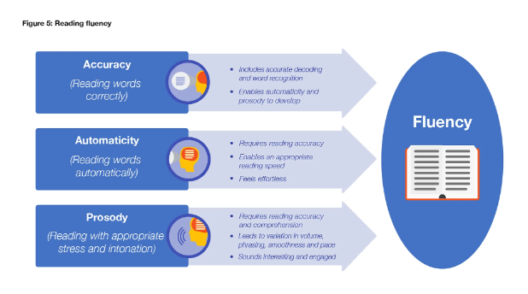
Link to the Parent Portal: https://parents.fft.org.uk/

Code: 4zksiy

