

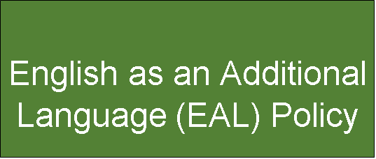

**St George’s Mission Statement**

Inspired by Gospel Values

And called to the fullness of life.

To learn and grow through faith, love, and laughter.

To be the best we can,

Showing Christ’s love in all we do.

|  |  |
| --- | --- |
| **Date of policy** | **October 2025** |
| **Date of last review** | **November 2024** |
| **Reviewed by** | **Senior Leadership Team** |
| **Date of next review** | **October 2026** |



# Introduction

The purpose of this policy is to outline St George’s approach to identification and meeting the needs of pupils who have English as an additional language.

This policy applies to all children; including those in the early years. In defining EAL we have adopted the following definitions:

* An EAL pupil is a pupil whose first language is not English. This includes pupils who are fully bilingual and all those at different stages of learning English.
* Newly arrived from a foreign country and school;

* Newly arrived from a foreign country, but an English- speaking school;

* Born abroad but moved to the UK at some point before starting school; or

* Born in the UK, but in a family where the main language is not English.

EAL pupils will need varying levels of provision.

# Aims

St George’s is committed to ensure that all pupils are enabled to have access to a broad, balanced and relevant curriculum. English is best learnt through the curriculum and EAL pupils should be encouraged to play a full part in all learning opportunities. Research supports EAL learners make the best progress within a whole school context, where pupils are educated with their peers.

(See[- https://www.bell-foundation.org.uk/app/uploads/2020/09/Integratingstudentsguidance-FV.pdf).](https://www.bell-foundation.org.uk/app/uploads/2020/09/Integrating-students-guidance-FV.pdf)

The school environment promotes language development through the rich use of language. The school structure, pastoral care and overall ethos help EAL pupils integrate into the school whilst valuing diversity. Bilingualism is viewed as a positive and life enriching asset.

Parents and prospective parents will be provided with an overview of our EAL provision.

# Welcoming EAL pupils into school with limited English

When pupils’ start their educational journey at St George’s, they receive a welcome pack to support their transition. This includes:

* A visual timetable for the school day;
* A picture of their class teacher and support staff;
* Pictures of their school uniform and the name of shops where these can be purchased;
* Two buddies so they can support interactions and dialogue;
* Placed at the front of the class to support facial communication with the class teacher;
* Receive a first language/English dictionary;
* Receive **picture:word** support at the beginning of each unit of work for key vocabulary.



# Identification and Assessment

Identification and assessments are carried out with the purpose of providing the most appropriate provision for each pupil. In assessing the nature and extent of the pupil’s grasp of English the following methods may be used:

* Information from the application form;

* Information from meetings with parents/carers;

* Information from initial assessment papers; and/

* Information from the previous school.

Whenever possible, assessment is undertaken as a partnership between the class teacher, EAL leader, parents/carers and pupil. In assessment of EAL pupils, competence in English is categorised on a five- point scale.

The department for Education uses the following EAL **classification codes**. These are the reference points for pupils on the EAL register. **English Proficiency**

[**https://assets.publishing.service.gov.uk/government/uploads/system/uploads/attachme nt_data/file/868209/English_proficiency_of_EAL_pupils.pdf**](https://assets.publishing.service.gov.uk/government/uploads/system/uploads/attachment_data/file/868209/English_proficiency_of_EAL_pupils.pdf)

**A: New to English**: May use first language for learning and other purposes. May remain completely silent in the classroom. May be copying/repeating some words or phrases. May understand some everyday expressions in English but may have minimal or no literacy in English. Needs a considerable amount of EAL support.

**B: Early acquisition**: May follow day-to-day social communication in English and participate in learning activities with support. Beginning to use spoken English for social purposes. May understand simple instructions and can follow narrative/accounts with visual support. May have developed some skills in reading and writing. May have become familiar with some subject specific vocabulary. Still needs a significant amount of EAL support to access the curriculum.

**C: Developing competence**: May participate in learning activities with increasing independence. Able to express self orally in English, but structural inaccuracies are still apparent. Literacy will require ongoing support, particularly for understanding text and writing. May be able to follow abstract concepts and more complex written English. Requires ongoing EAL support to access the curriculum fully.

**D: Competent**: Oral English will be developing well, enabling successful engagement in activities across the curriculum. Can read and understand a wide variety of texts. Written English may lack complexity and contain occasional evidence of errors in structure. Needs some support to access subtle nuances of meaning, to refine English usage, and to develop abstract vocabulary. Needs some/occasional EAL support to access complex curriculum material and tasks.

**E: Fluent**: Can operate across the curriculum to a level of competence equivalent to that of a pupil who uses English as his/her first language. Operates without EAL support across the curriculum.

**N: Not Yet Assessed** is also available for use where the school has not yet assessed proficiency **Provision**

The provision for children with EAL is expressed in terms of ‘learning support’- an umbrella term indicating the provision for a variety of types and levels of need, including SEND, EAL and Higher Achieving Pupils. This provision encompasses curriculum planning, support for individual pupils or groups of pupils within the classroom in terms of differentiation, support for staff teaching EAL pupils and supplementary provision. EAL pupils will be provided with opportunities to make good progress and where appropriate, assess understanding in their home language in order to inform an assessment judgement in the early stages of English language learning.

Class teachers have responsibility for ensuring that pupils can participate in lessons and will have an awareness of good practice in providing for EAL pupils within the classroom setting. Our school aims to address the needs of EAL pupils within the classroom. However, there may be times when it will be appropriate for children to be withdrawn from lessons to receive focused support.

# Communication

Parents and teachers will work together in the best interests of pupils and families with EAL. Teachers will meet with parents who have children with EAL when they begin their journey at our school. This information will be used alongside any assessment information to plan for the learning needs of the EAL pupil. Teachers will meet with parents at parents’ evening to inform them of progress made and to discuss strategies in place if there is a ‘Person Centred Plan’ - PCP in place. It may be appropriate to hold this meeting separately as an interpreter may be required.

# Special Educational Needs and Differentiation

EAL pupils are not children with special educational needs/disabilities (SEND) and our school recognises that most EAL pupils needing support with their English do not have SEND needs but have skills and knowledge about language similar to monolingual English-speaking children. Their ability to participate in the full curriculum may be in advance of their communicative skills in English. Some EAL pupils may have a special educational need and in such cases; pupils will have equal access to school SEND provision, in addition to EAL support. EAL pupils with a special educational need will be identified as part of normal assessment procedures as outlined in our SEND policy. EAL pupils considered to be more able or to have an individual talent will be identified as part of normal assessment procedures.

# Monitoring and Evaluation

**Class Teachers will:**

* Be responsible with the support of the EAL Lead to maintain up to date records of EAL pupils in their class whilst they are in their care;

* support of the EAL Lead, provide buddies to support EAL pupils’ social confidence and access dialogue between peers;

* differentiate teaching and learning to support access and understanding;

* Complete a PCP (Person Centred Plan) for all EAL pupils assessed as having a competency in English at stage A, B or C. This is reviewed on a termly basis;

* receive CPD training on supporting pupils in the classroom who are identified as EAL.

**EAL Lead will:**

* collate information and arranges a baseline for EAL pupils

* maintain a register of EAL pupils (identifying stages) collated centrally by the school and monitored by the EAL Lead

* support class teachers with differentiated provision within the classroom

* collaborate with other schools and agencies in order to improve provision and practice within the school.

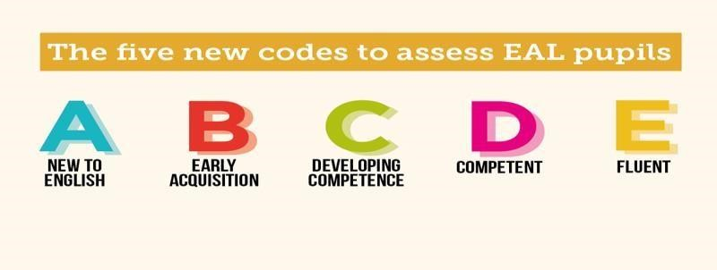

# Sources of Information

The NALDIC website is the main source of information for all matters relating to EAL provision.

* <https://naldic.org.uk/>
* [https://www.bell-foundation.org.uk/app/uploads/2020/09/Integratingstudentsguidance-FV.pdf](https://www.bell-foundation.org.uk/app/uploads/2020/09/Integrating-students-guidance-FV.pdf)
* <https://cdn.oxfordowl.co.uk/2017/08/10/09/32/48/468/bp_eal_guide.pdf>